The Hitchhiker’s Guide to PID & Odometry Config! ☆

Welcome adventurer, to the world of Vex robotics programming! Hopefully your intake building and mogo fixing has been going great, but now, its where the real shit begins!!!

Main Quest – Configure The Odometry Sensors (Line 42 to 65)
You see, odometry, which seems like black magic, is rly just tracking the robots’ position on the field, with really good sensors and math. (really just simple trig)

Thus, we need to have the program know what wheels we r using, and where they are.

(If you read the thing in Line 43, come here)
The Below, is an extract from the LEMLIB DOCS that details how to setup these sensors in lemlib:
Source: https://lemlib.readthedocs.io/en/stable/tutorials/2_configuration.html
Now that we have the encoders configured, we need to determine the offset of the tracking wheels. The offset of the tracking wheel is equal to the length of the line perpendicular to it that ends at the tracking center. To help us understand, let’s take a look at the diagram below:
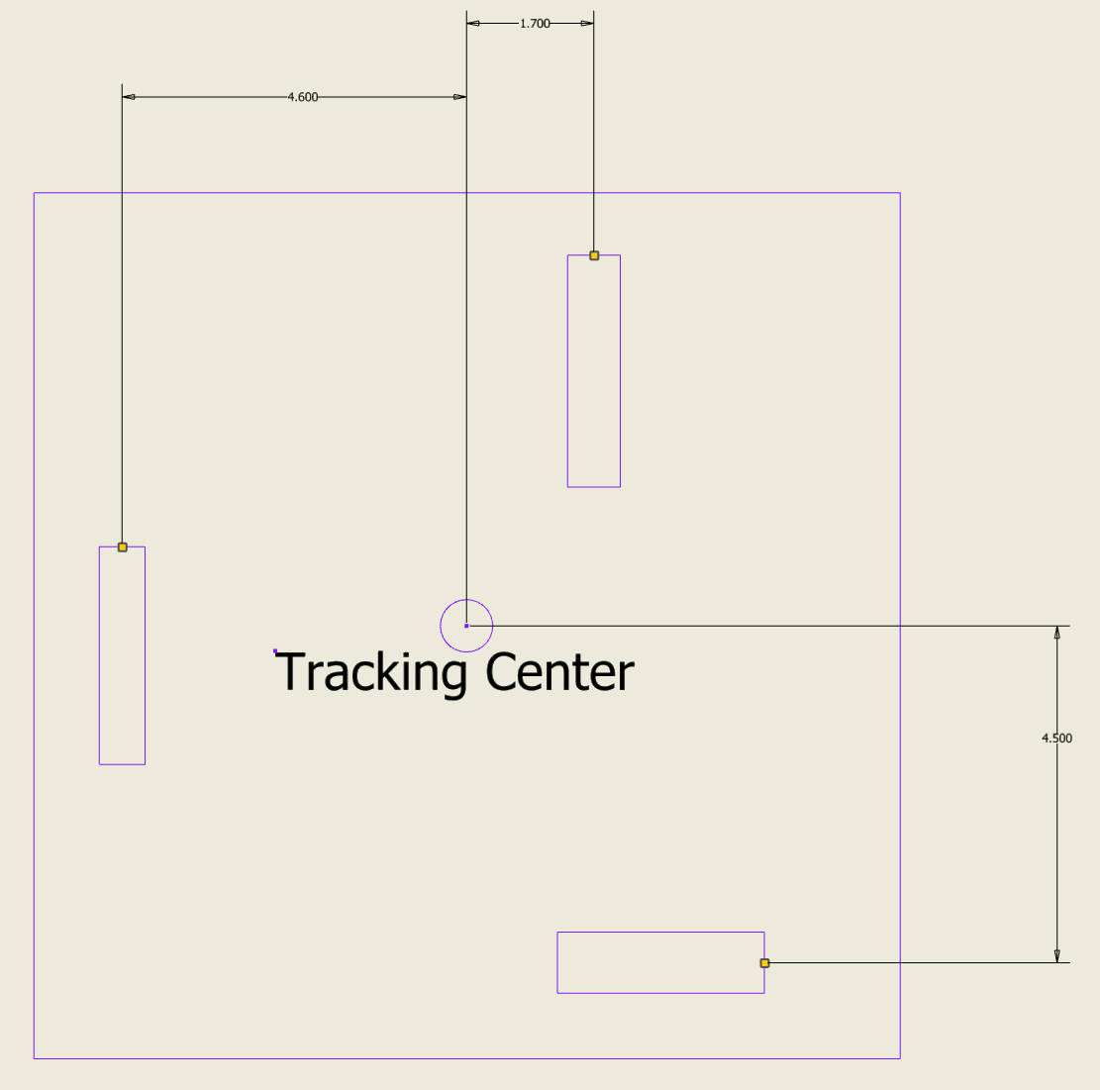
In the diagram, there are 3 tracking wheels: one vertical tracking wheel on the left with an offset of 4.6”, one vertical tracking wheel on the right with an offset of 1.7”, and one horizontal tracking wheel at the back with an offset of 4.5”
The offset of a tracking wheel can be positive or negative, depending on whether its a vertical or horizontal wheel and where it is relative to the tracking center. See the tables below:
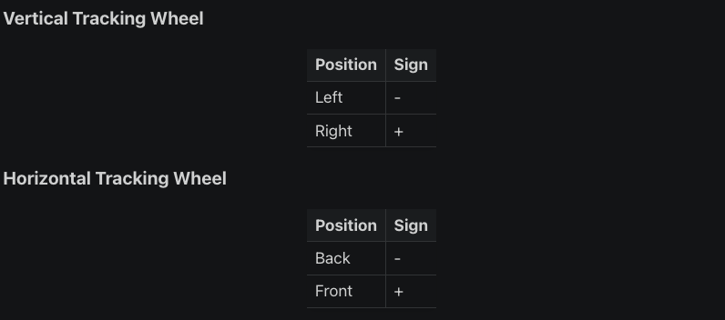
Fore more detailed info, read under ODOMETRY under the given link:
https://lemlib.readthedocs.io/en/stable/tutorials/2_configuration.html

Final Boss – Tuning PID Controller (Lines 85 - 149)
This part is really important, please pay close attention and read all information.
Conventionally, PID would be tuned with MATH, but we don’t know jackshit in math so do it instead with ur EYES. This is called manual PID tuning.
Essentially PID wants to be a perfect Log graph that does not overshoot but maximises acceleration. So read this from Wikipedia.
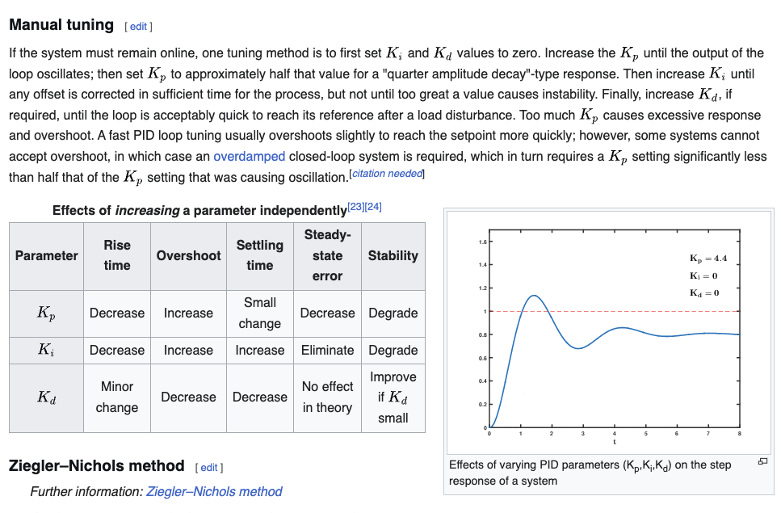
For me, the GIF diagram also helped me a lot to visualise what PID tuning is supposed to look like, so feel free to talk a look at it:
https://en.wikipedia.org/wiki/Proportional%E2%80%93integral%E2%80%93derivative_controller#/media/File:PID_Compensation_Animated.gif
I have already preset the PID params that I think are somewhat reasonable for this chassis, so u can start from there, but I wouldn’t rely on it.

Also, I have attached the “Intro to PID” doc in this folder, give it a read if u want to know more about PID or still don’t quite understand PID yet.

The code I would use for PID tuning are in the “AUTONOMOUS” function, uncomment the part u want, type PROS MU (no cap obviously), and run in auton skills mode.

Good Luck Adventurer!
Count Alexander Richard Jonathan Tony George Rev Hobba Edward Foxwell The Second

